Test Plan and Log

# Test Plan and Log

The functions in the project were unit tested. Afterwards a system and integration test was performed.

|  |  |  |  |  |
| --- | --- | --- | --- | --- |
| Name of Project: | Quidditch | | Date: 17.12.2020 |  |
| Test run / case | Data Used | Expected Result | Actual Result | Action Taken |
| 1. Normal: draw(), str() | Game is running | Map of the level is displayed | Map of the level is displayed | nfa |
| 1. Normal: printPoints(), getPoints() | seeker catches the snitch | Points are displayed on the screen, after catching snitch, score changes | Points: Team A 0 : 0 Team B -> Points: Team A 150 : 0 Team B | nfa |
| 1. Normal: printPoints(), getName() | Game is running | Next to the Points are presented the team names | Points: Team A 0 : 0 Team B | nfa |
| 1. Normal:   addPoints(),  awardPoints() | seeker catches the snitch | the winning team receives 150 points | Points: Team A 150 : 0 Team B | nfa |
| 1. Normal:   printMoves(),  getMovesMade() | Seeker makes a move | Moves are displayed on the screen, after each move counter increases | The counter has changed | nfa |
| 1. Nomal:   addMovesMade() | Seeker makes a move | The moves counter increase after each move | The counter has changed | nfa |
| 1. Nomal:   setMovesMade() | going to next level | At the start of each level the counter is reset | Moves: Team A 0: 0 Team B | nfa |
| 1. Normal:   printLevel() | Going to next level | The current level is displayed, it increase when going to next | Level 1 -> Level 2 | nfa |
| 1. Normal: newLevel(), getMaxLevel(), setLevel() | Going to next level | After completing level 1, level 2 is displayed | Level 2 | nfa |
| 1. Normal: noMoreLevels() | Completing last level | Function ends the game, doesn’t allow to try to load next level | Game ends after Level 2 | nfa |
| 1. Normal:   stillPlaying(), isFree() | Catching the golden snitch | The level is running as long snitch is free | The level is running as long snitch is free | nfa |
| 1. Normal:   checkSnitch(),  captured(), getRow(), getColumn() | Catching the golden snitch, seeker and snitch has the same coordinates | Snitch is marked as captured, no longer visible in this level | The next level is displayed or game ends if last level | nfa |
| 1. Normal: reset() | Going to next level | Seekers and snitch on starting positions, moves counter reset | Seekers and snitch on starting positions, moves counter reset | nfa |
| 1. Normal: move(), setRow(), setColumn() | Objects are moving, seekers and from lvl2 snitch as well | Seekers and snitch are moving | Seekers and snitch are moving | nfa |
| 1. Normal: recognizeInput() | User presses ‘WSAD’ or arrow keys | Seeker is moving in the given direction if no obstacles | Seeker is moving in the given direction if no obstacles | nfa |
| 1. Normal: newPostion(), isPositionFree(), clearPosition() | User presses ‘WSAD’ or arrow keys | Function check if object can go to new position, if yes then free up the old space | Object cannot go into walls, only one object at a time is displayed | nfa |
| 1. Normal: updatePitchSeekers(), placeOnPitch() | User presses ‘WSAD’ or arrow keys | Place new position of seekers on the pitch | Seekers are displayed properly on the pitch | nfa |
| 1. Normal: updatePitchSnitch(), placeOnPitch() | From lvl 2 snitch is moving | Place new position of Snitch on the pitch | Snitch is displayed properly on the pitch | nfa |
| 1. Normal: moveSnitch(), isPlayerOnPosition() | Level 2 | If no seeker is nearby (one field), snitch moves random, if a seeker is next to then snitch goes to the other direction | Snitch runs away from seekers | nfa |
| 1. Normal: update() | Game is running, seekers and snitch are moving | All objects are moving as they should | All objects are moving as they should | nfa |
| 1. Exceptional: regonizeInput() | User presses random keys in lvl 1 | Nothing happens | Nothing happens | nfa |
| 1. Exceptional: regonizeInput() | User presses random keys in lvl 2 | Snitch makes a move | Snitch makes a move | nfa |
| 1. Normal: terminate() | User clicked the X at the corner of the window | Program ends without an error | Program ends without an error | nfa |
| 1. Normal: terminate() | All level are solved | Program ends without an error | Program ends without an error | nfa |
| 1. Noraml: drawMap() | Game is running | Every object and map are displayed on the screen as tiles | Map and objects displayed properly | nfa |

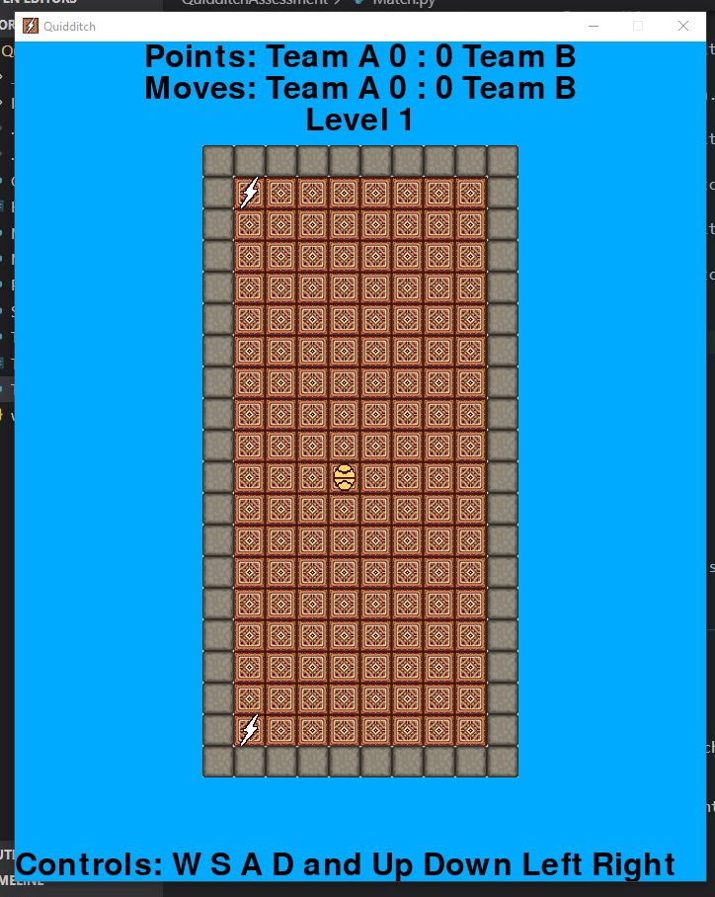  
1.

  
2.

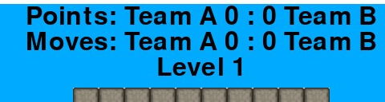  
3.

  
4.

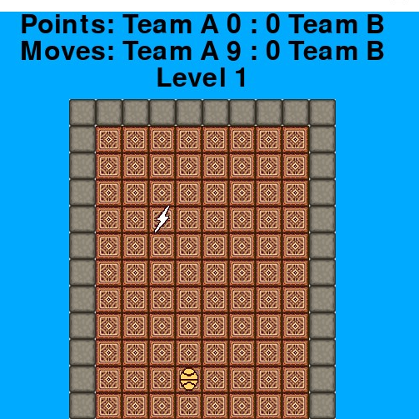  
5.

  
6.

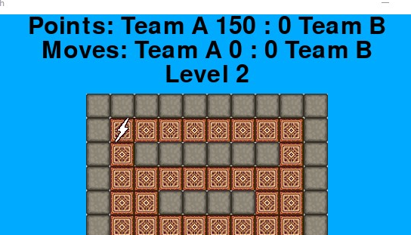  
7.

  
8.

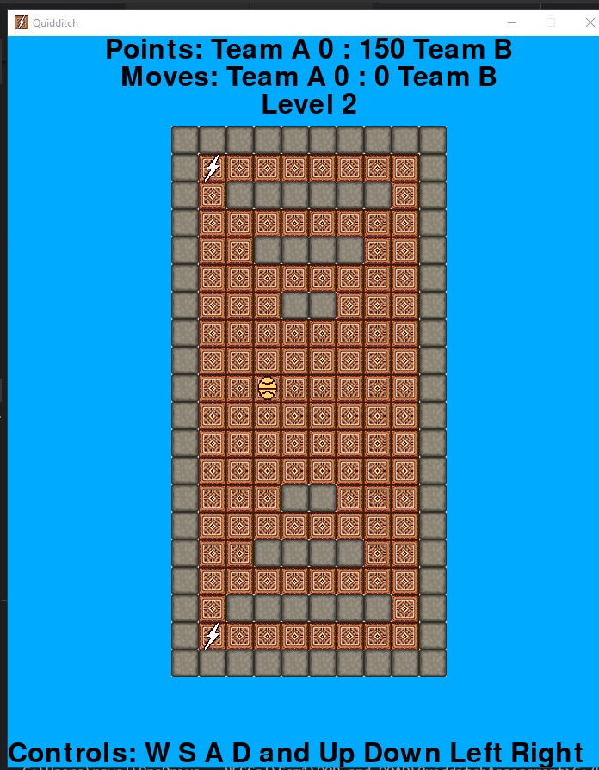  
9.

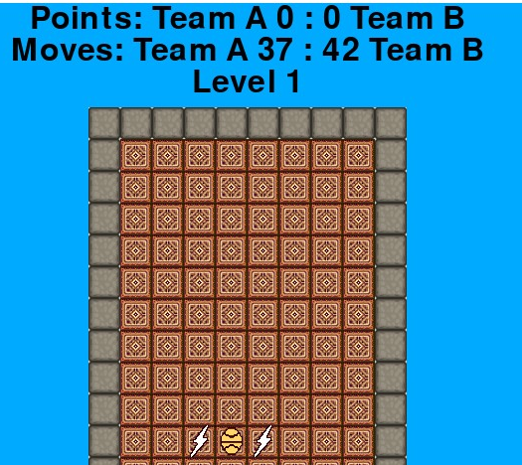  
11.

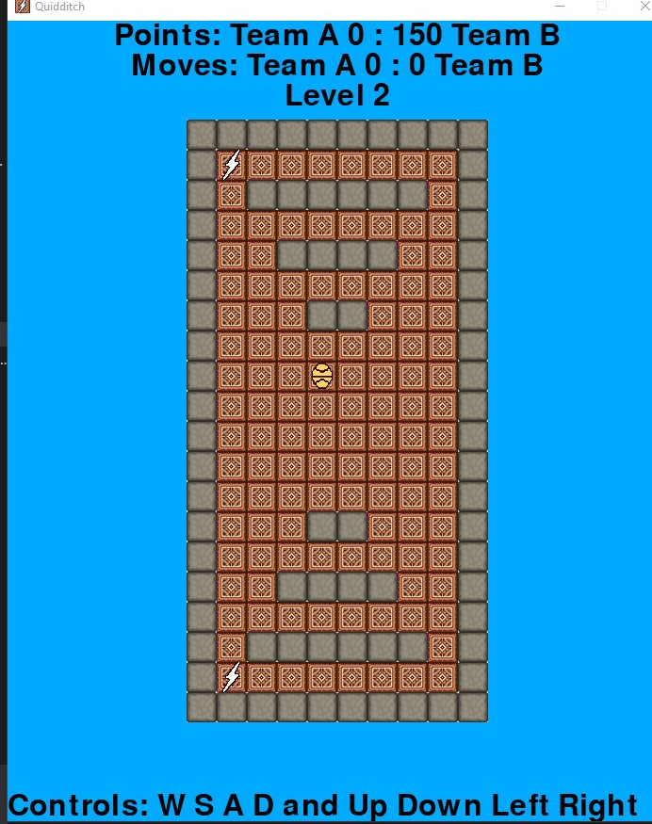  
13.

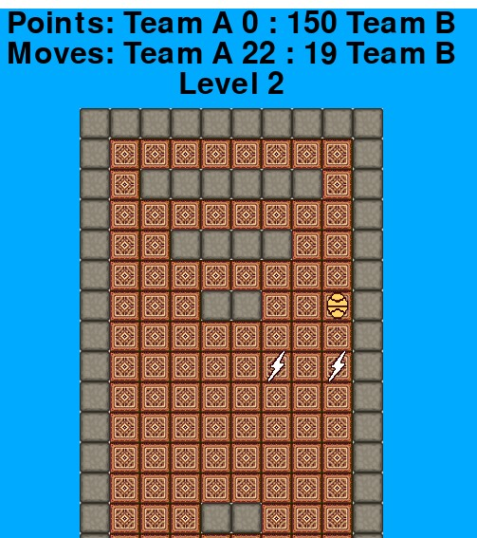  
14.

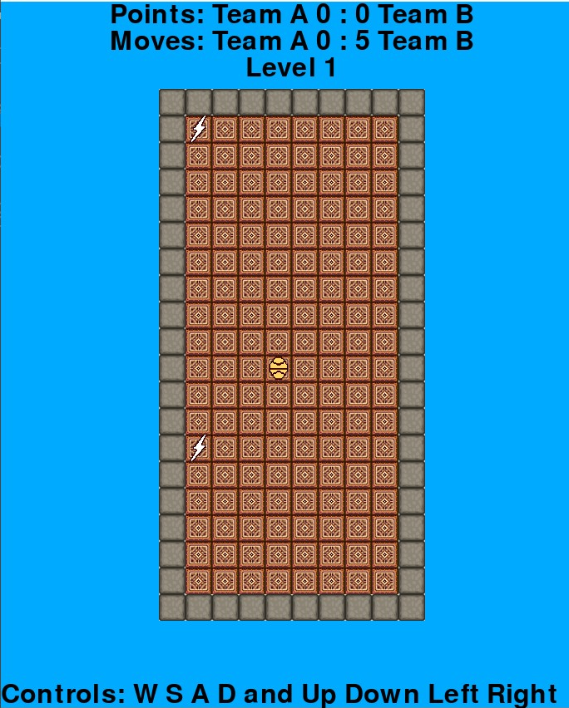  
15.

  
16.

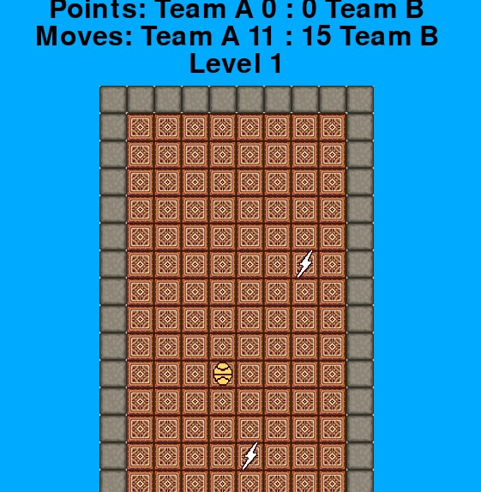  
17.

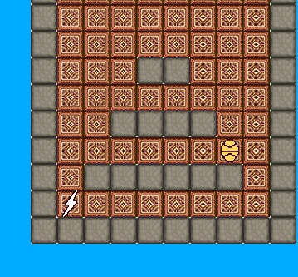  
18.

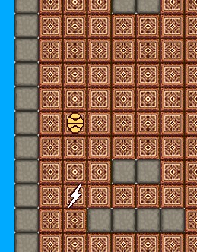  
19.

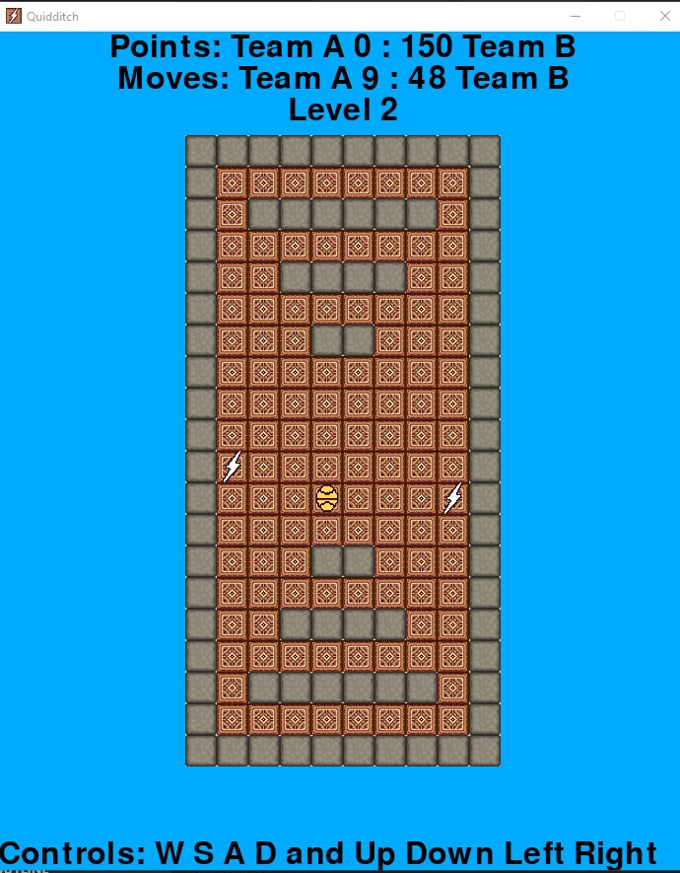  
20.

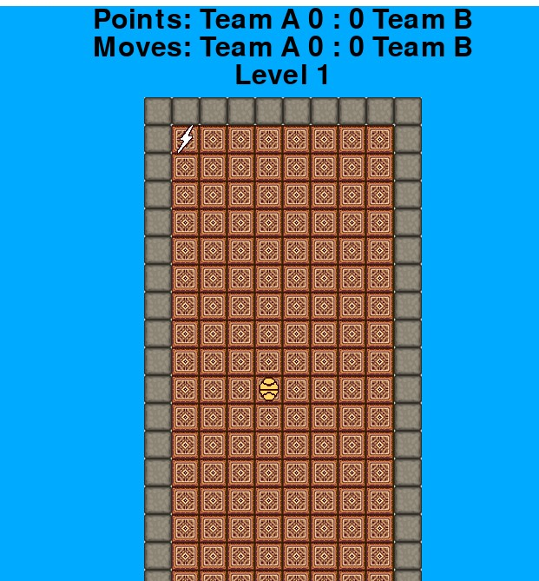  
21.

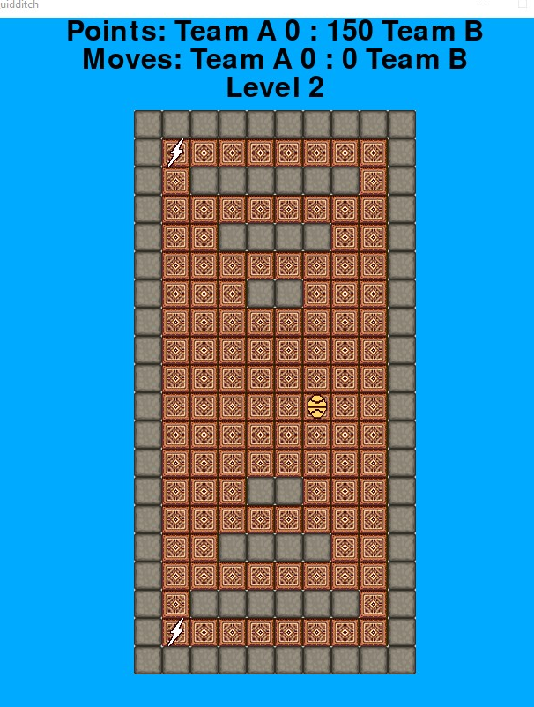  
22.

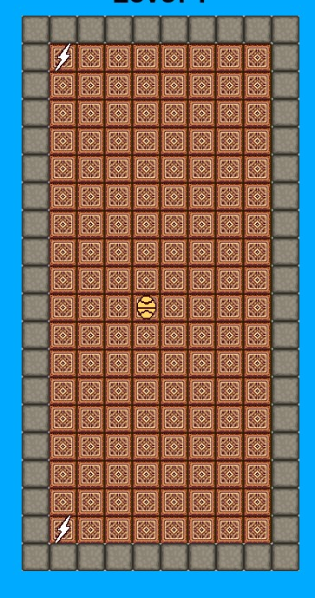  
25.